EXPERIMENT 15
Harris Corner Detection Using Python and OpenCV
Aim:
To read an image and detect its corners using the Harris Corner Detection function in OpenCV.
Procedure:
- Import OpenCV and NumPy libraries.
- Read the input image.
- Convert the image into grayscale.
- Apply Harris Corner Detection using cv2.cornerHarris().
- Highlight the detected corners.
- Display the output image.
Program:
import cv2
import numpy as np

img = cv2.imread('image.jpg')

gray = cv2.cvtColor(img, cv2.COLOR_BGR2GRAY)
gray = np.float32(gray)

corners = cv2.cornerHarris(gray, 2, 3, 0.04)
corners = cv2.dilate(corners, None)

img[corners > 0.01 * corners.max()] = [0, 0, 255]

cv2.imshow('Harris Corner Detection', img)

cv2.waitKey(0)
cv2.destroyAllWindows()
Input:

Output:
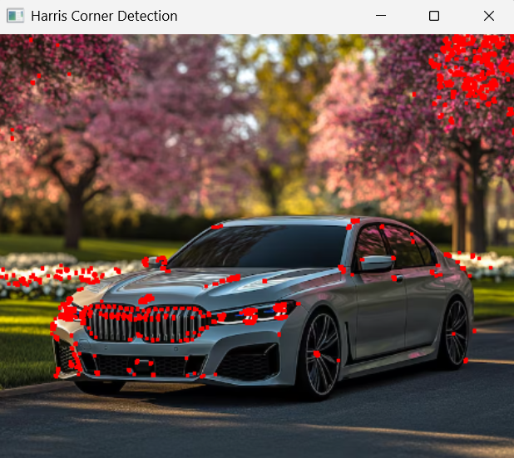
Result:
Thus, Harris Corner Detection was successfully performed, and the detected corners were highlighted in the image using Python and OpenCV.

